**Cup-playing Robot**

|  |  |
| --- | --- |
| **Part Name** | **Model** |
| Micro Servo | FS90 |
| Micro Continuous Rotation Servo | FS90R |
| MCU | ESP8266-12E |
| Motor Shield | ESP-12E Motor Shield |

This cup-playing robot uses an MCU with built-in Wi-Fi to control movement of two motors that can hit on cups to make noise. The continuous rotation servo (servo 1) is fixed, and there is a stick connected perpendicular to its axis. On the other end of the stick is the regular servo (servo 2). There is another stick connected perpendicular to its axis (Figure 1). The second servo can move both clockwise and counterclockwise in a circle centered at the first servo, and the second stick can move up and down to strike on cups.

Table 1: Bill of materials

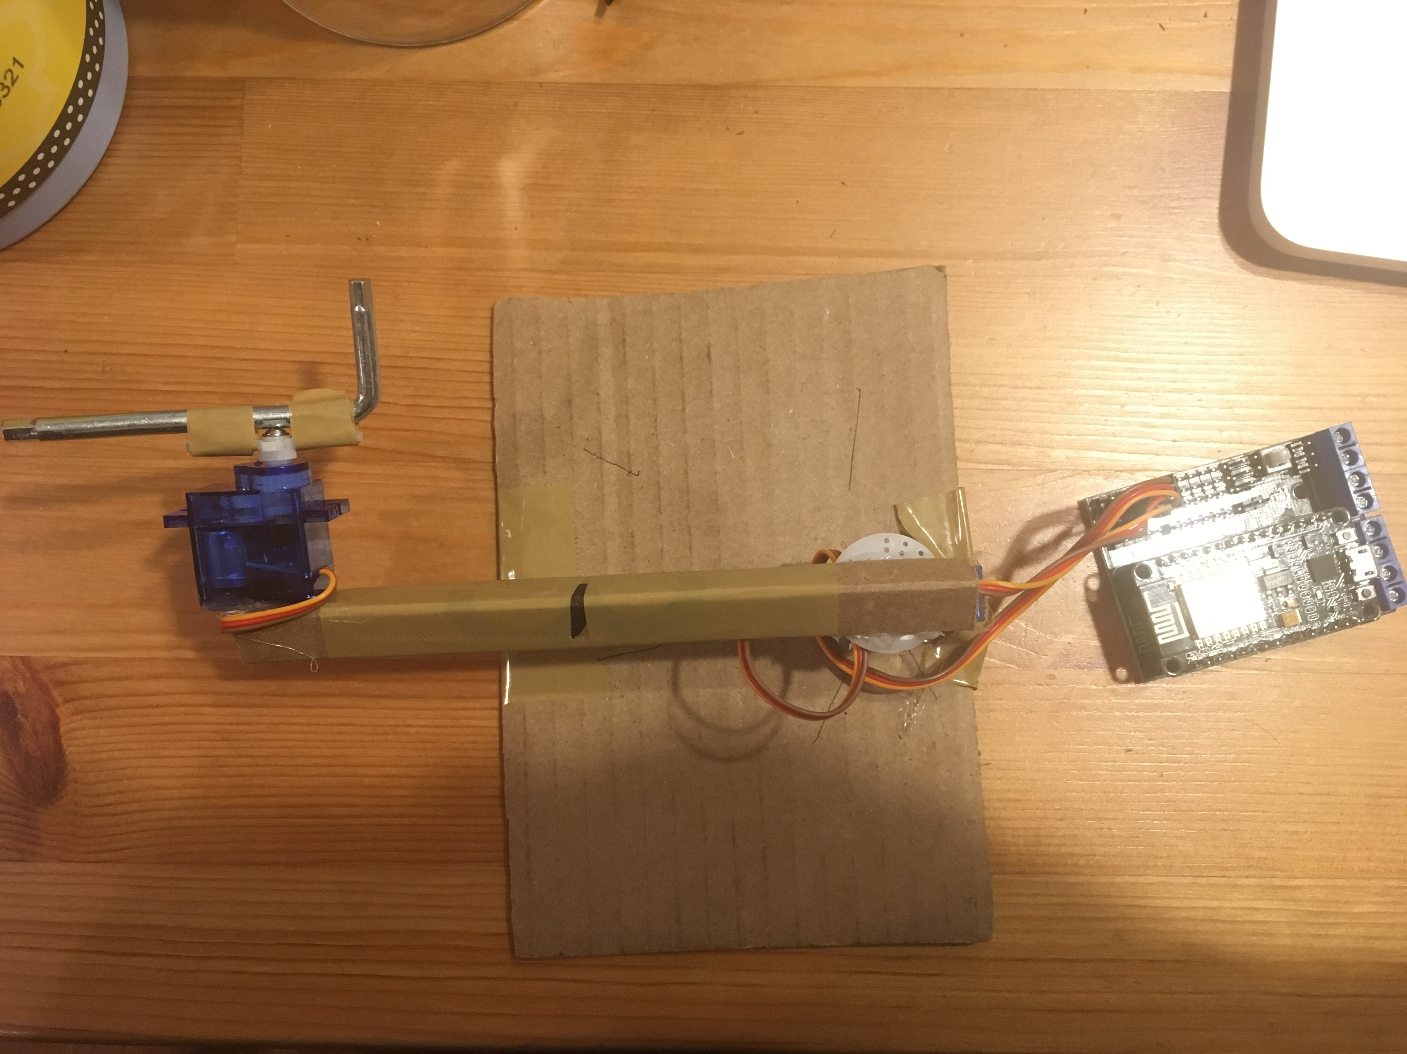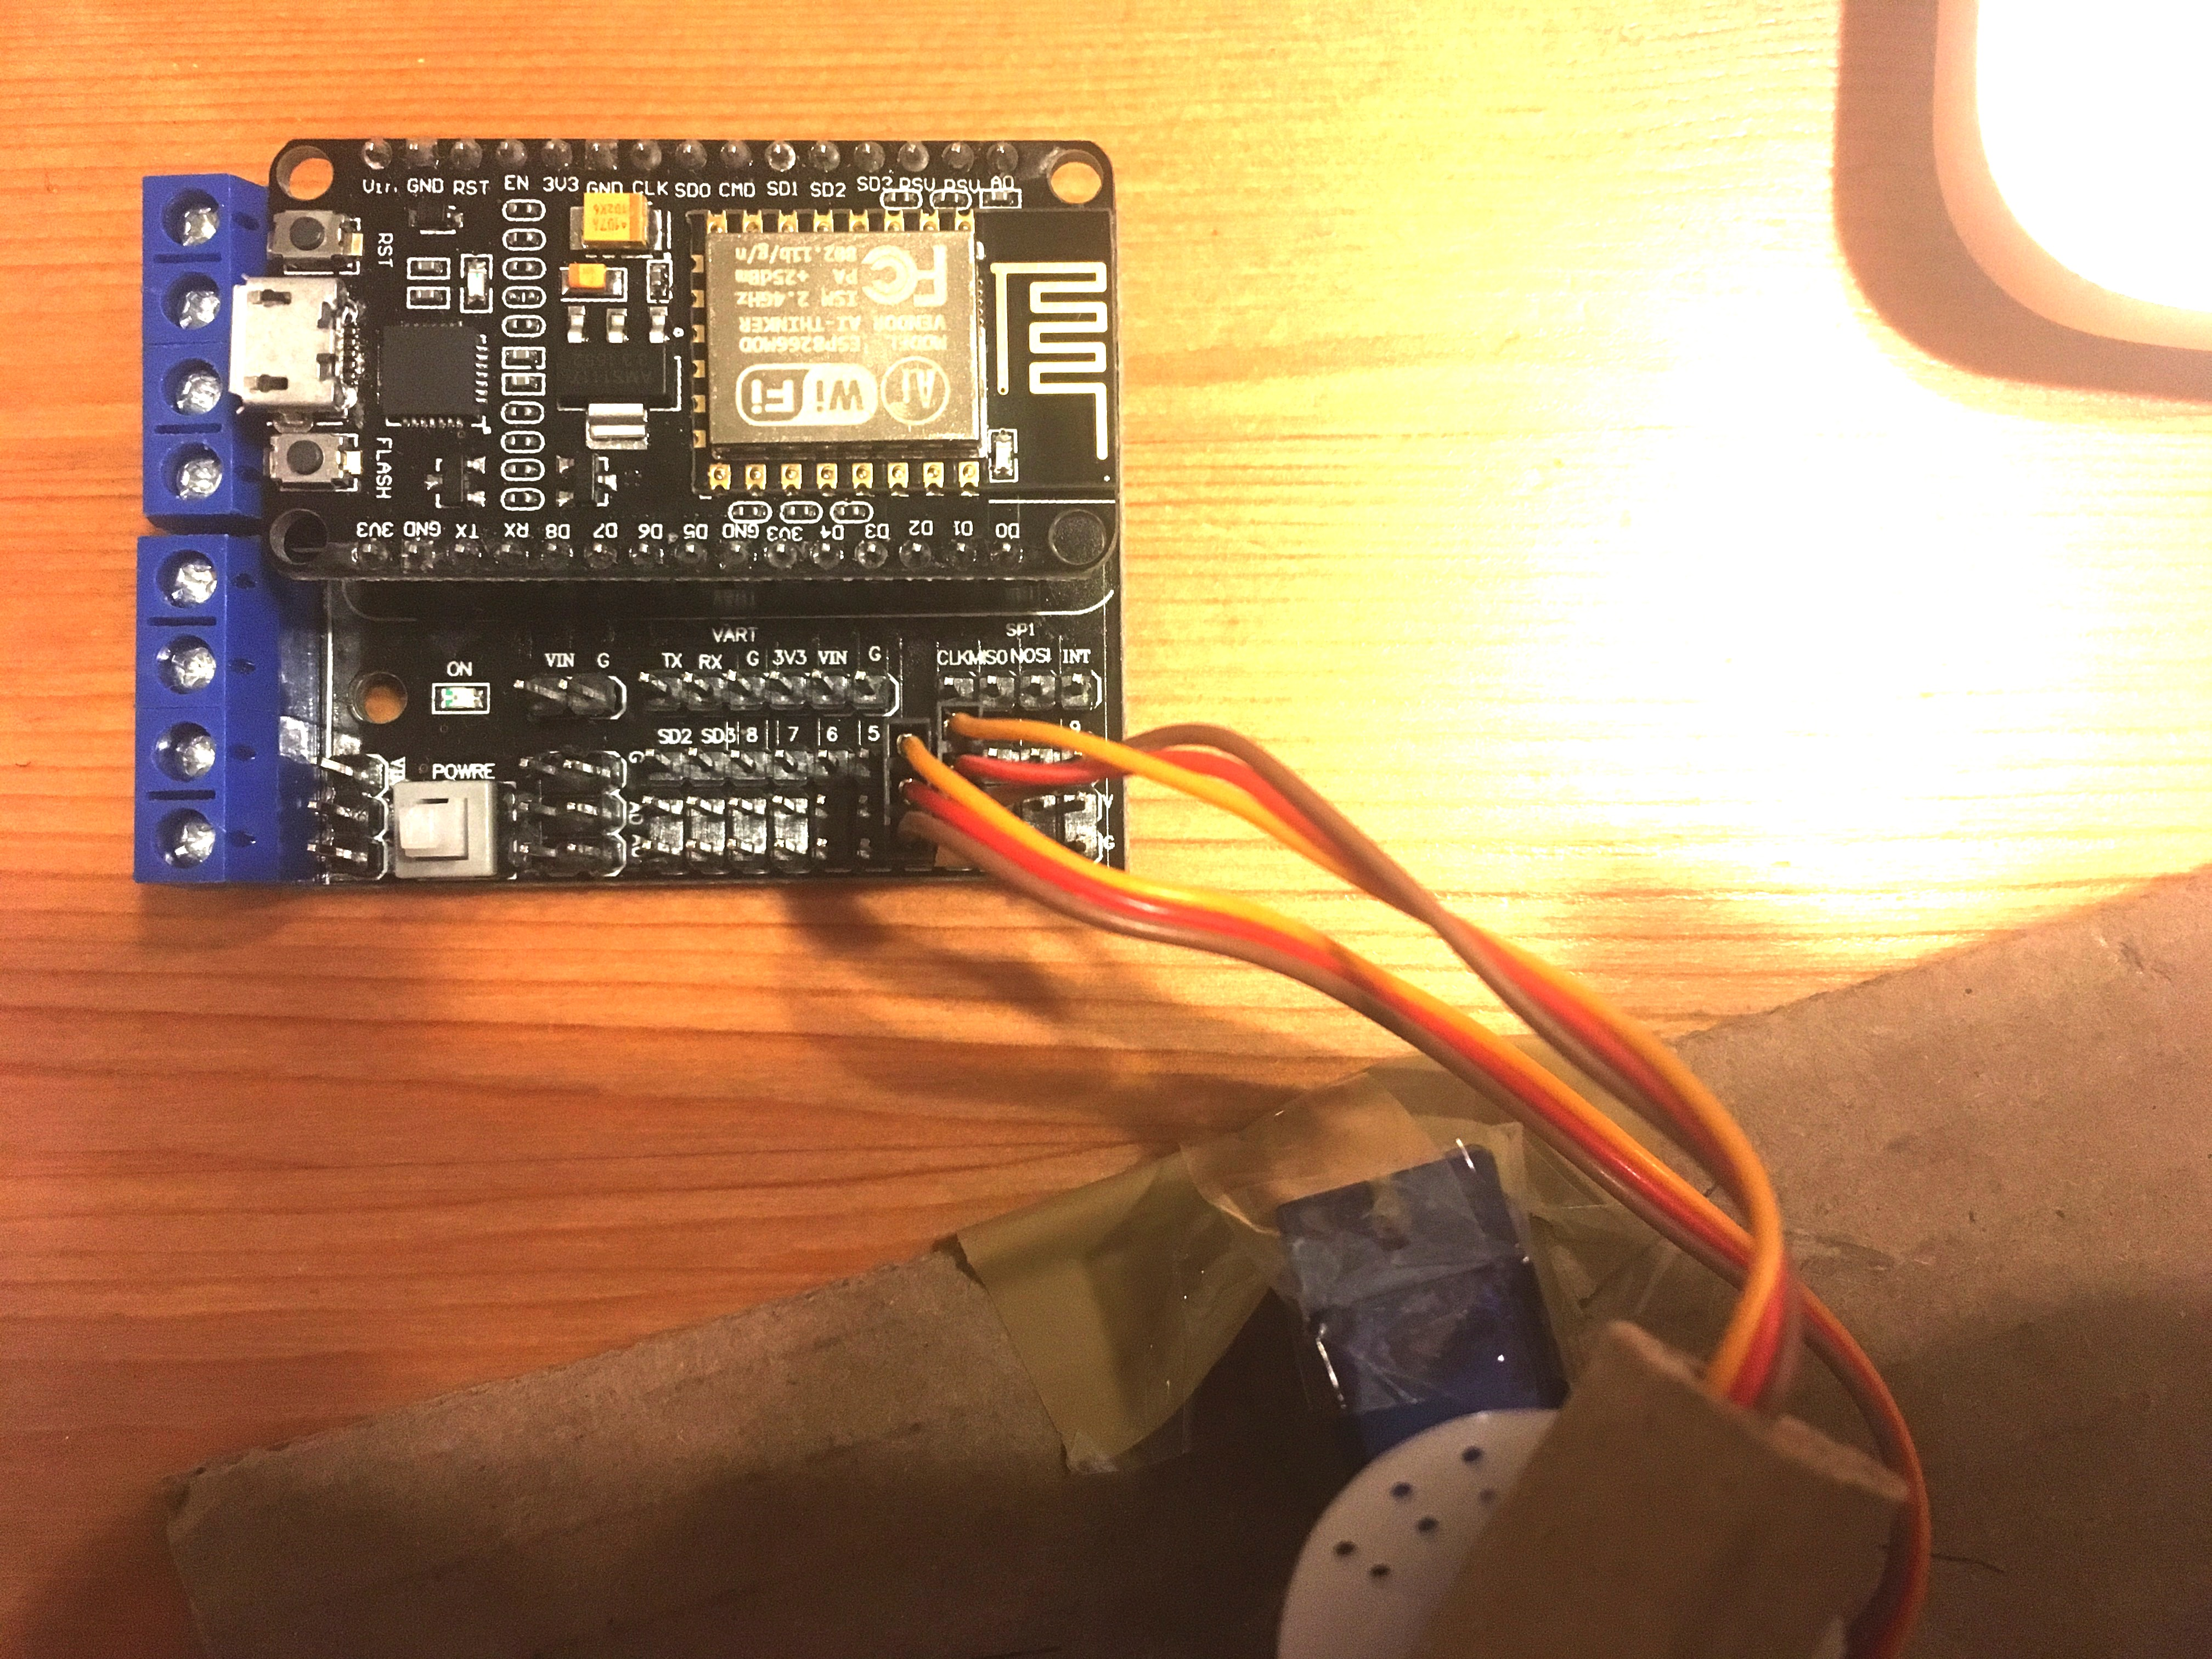

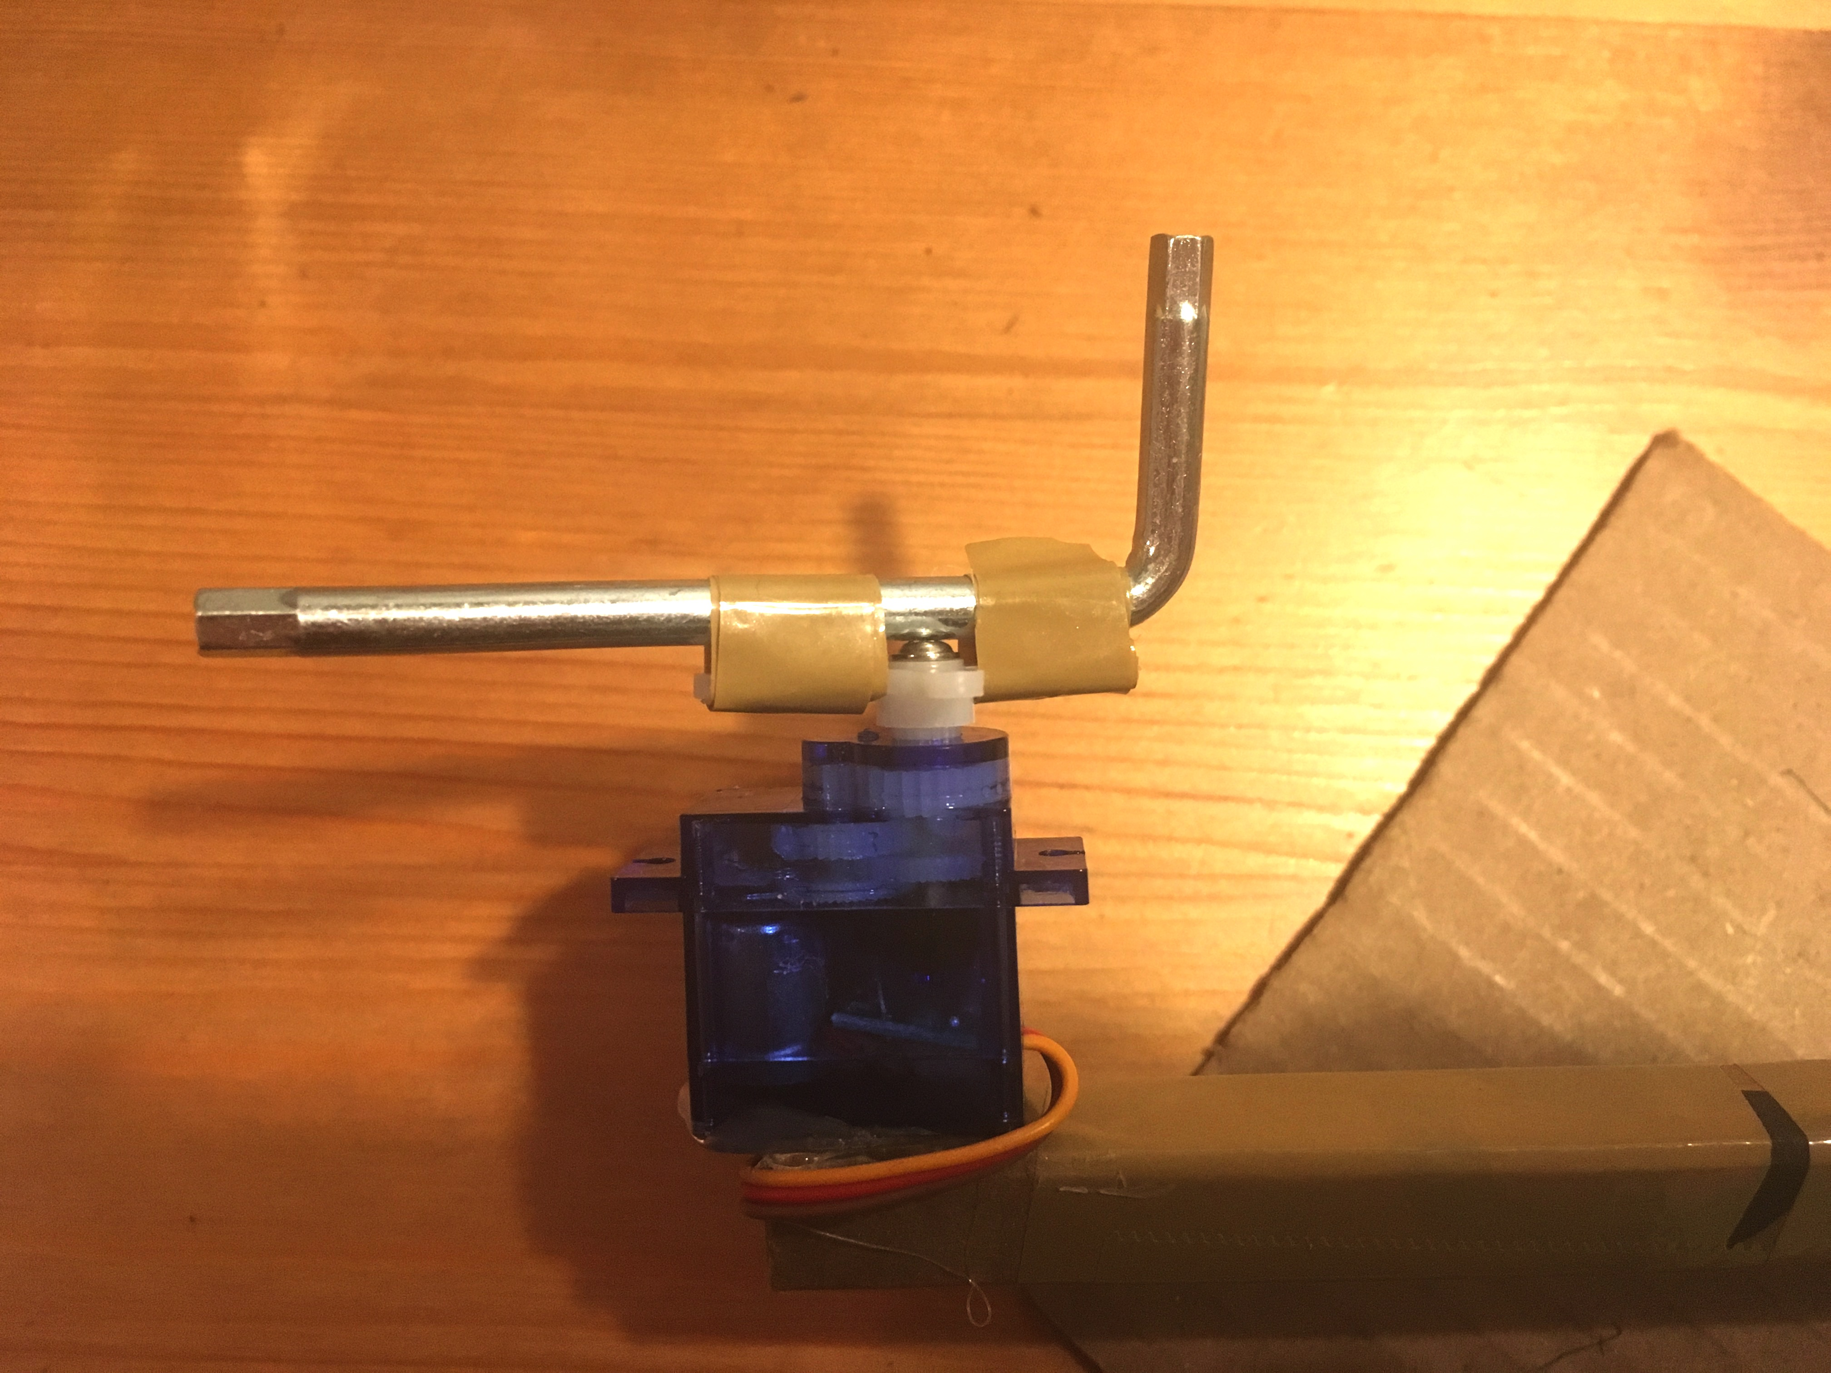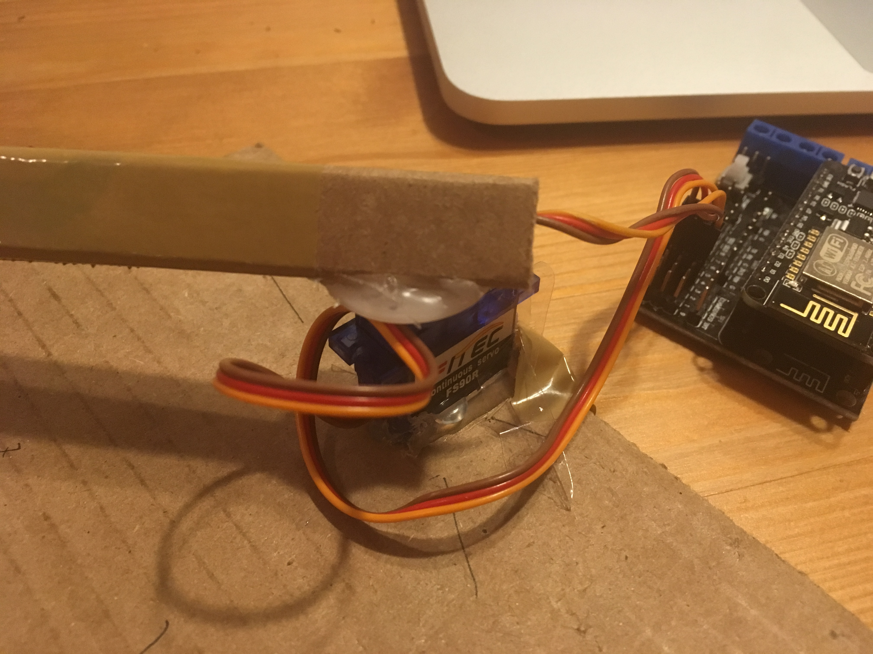

Figure 1: picture of the robot

To use the cup-playing robot, first you need 6 cups. Name cups from 1 to 6 where cup 1 has lowest pitch, cup 2 has the second lowest pitch and so on (you can fill them at different levels so they will sound differently). Put the cups equidistantly in an arc along the track of the second servo so that each cup has a higher pitch than the one on the left of it, and point the robot’s arm at the starting position: left of the first cup (Figure 2). The robot has a built-in song “Twinkle Twinkle Little Star” which the user can play by clicking on the corresponding button on the website (http://192.168.4.1/). Users can also create their own songs. For example, if user wants to play cup 3, then cup 4, he can just click button “play3” and then “play4”. A demonstration of the cup-playing robot can be found on YouTube: https://youtu.be/anb9a0QAz5c.

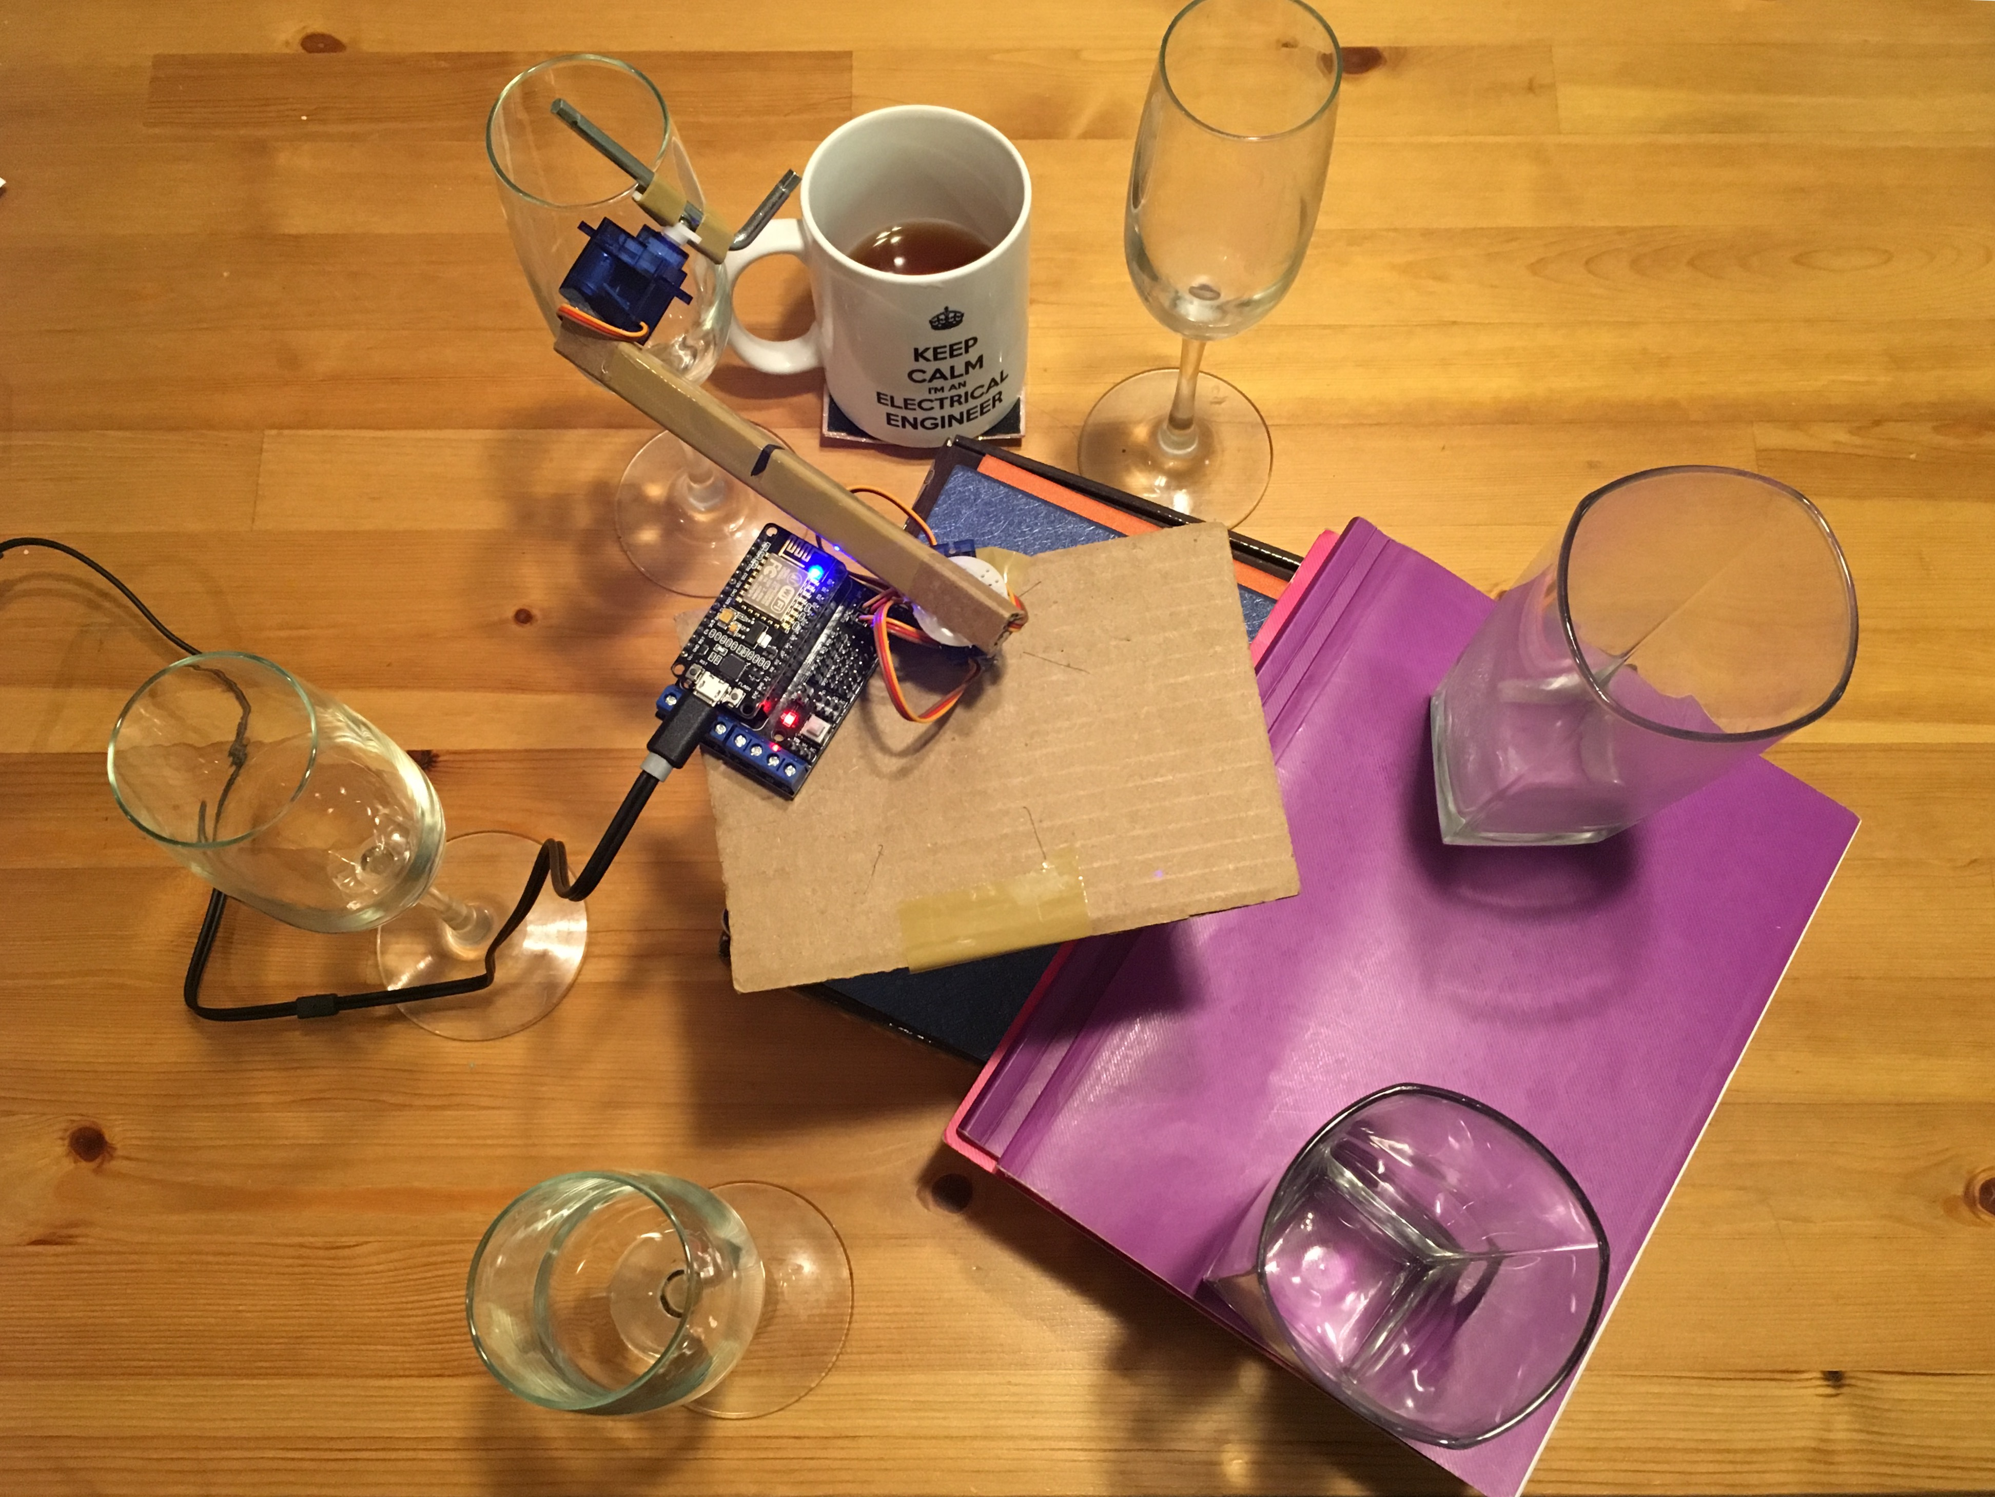

Figure 2: how to use the cup-playing robot

MCU can control the rotational angle of the standard servo, and the angular speed of the continuous rotation servo. The two servos are arranged this way because standard servo can only rotate 180°, thus cannot access all cups around it. I can still control the rotational angle of the continuous rotation servo by controlling how long it rotates. The regular servo is connected to pin D3 on the motor shield and the continuous rotation servo is connected to pin D4. The MCU and its motor shield are just connected the way they are designed to.

The code I wrote can be found in <https://github.com/yanhan2017/EE183DA_lab2>. The main code is in run_motor.ino, and the functions used are implemented in functions.ino. To make sure the time intervals between each two strikes are the same no matter how much distance we need to move, I first compute the difference (diff) between my current position and the desired position, then make the continuous rotation servo’s speed inversely proportional to the difference. Then I make sure every rotation lasts for “period” microseconds (period = 250), now the movement between each pair of positions will take the same amount of time. Note that because motors are more efficient in spinning clockwise than counterclockwise, I specified different speeds for different directions. For clockwise spinning, I used

sr.write(90 + 90/(npos+2)*diff);

delay(period + delay1*diff*sqrt(diff));

sr.writeMicroseconds(1400);

And for counterclockwise spinning, I used

sr.write(85 + 85/(npos)*diff);

delay(period + delays*(-diff)*sqrt(-diff));

sr.writeMicroseconds(1400);

(“npos” represents the number of cups used, and is initially set to 7)

There are several modifications that can be done to the robot. For example, if the user wants other number of cups instead of 6, he can change “npos” into the number he wants (and maybe also change the time that the R servo spins). From the video we can see that the robot doesn’t always act ideally. The distance it moves is not simply velocity multiplies time, because the motor needs time to speed up and speed down, and it has different efficiency when spinning forward and backward. To improve performance, we need a better knowledge about how the motor’s angular displacement relevant to it’s velocity and delay time, also we need a better setup (6 identical and larger cups will be better). Feedback control can also be used to improve precision. Another approach to improve performance is to exchange the regular servo and the continuous rotation servo.